Experiment 2 : Develop a program to blink 5 LEDs back and forth
Date : 12.08.2025
Aim:
To interface a relay with an Arduino board, the following program can be used to toggle the relay on and off at regular intervals.

Components Required:
S.No | Components Name | Range/Rating | Quantity
1 | Universal Bread Board |  | 1
2 | Arduino Uno board |  | 1
3 | 5 volt relay |  | 1
4 | LED or Bulb with holder |  | 1
5 | 12V Adaptor |  | 1
6 | Power jack |  | 1
7 | USB Cable |  | 1
8 | Jumper Wires |  | required

Hardware Procedure:
- Connect the VCC pin of the relay module to the 5V pin on the Arduino.
- Connect the GND pin of the relay module to a GND pin on the Arduino.
- Connect the IN (or signal) pin of the relay module to a digital pin on the Arduino (e.g., Digital Pin 7)

Connection Diagram:-
For DC Device
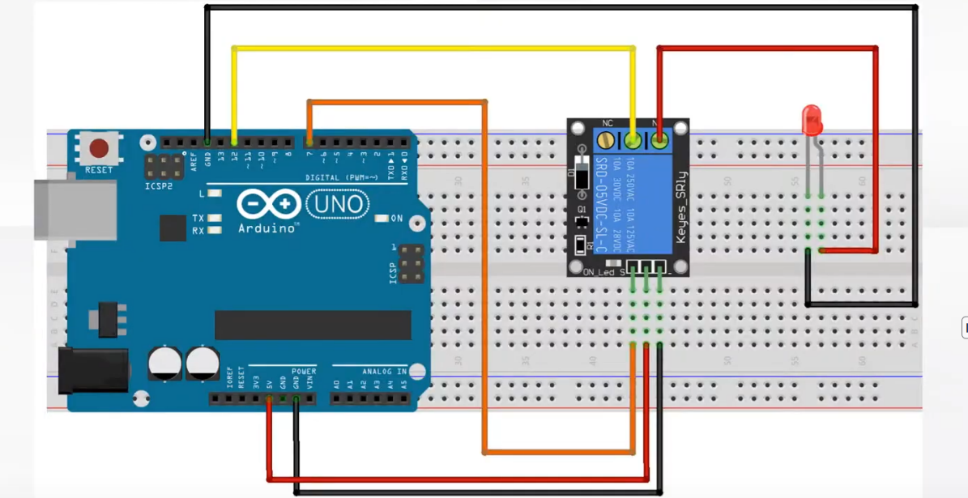
For AC Device
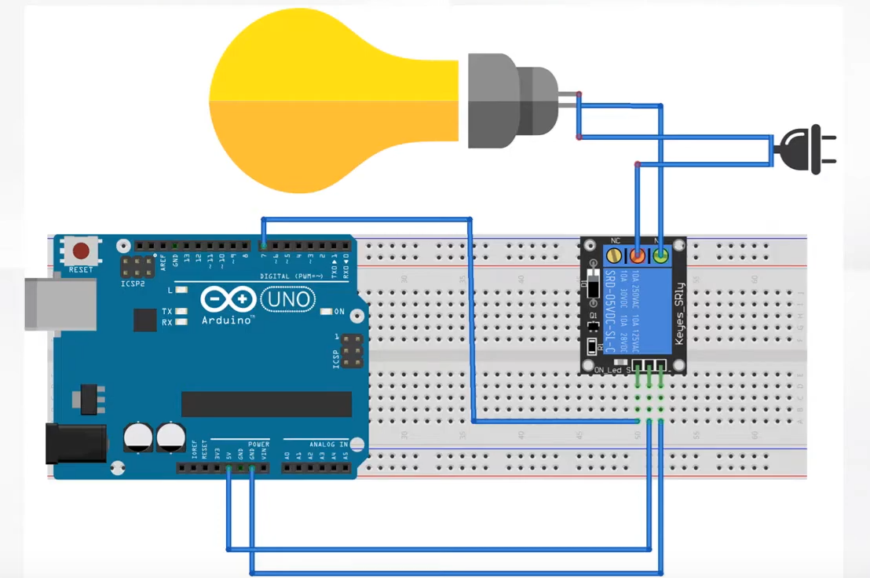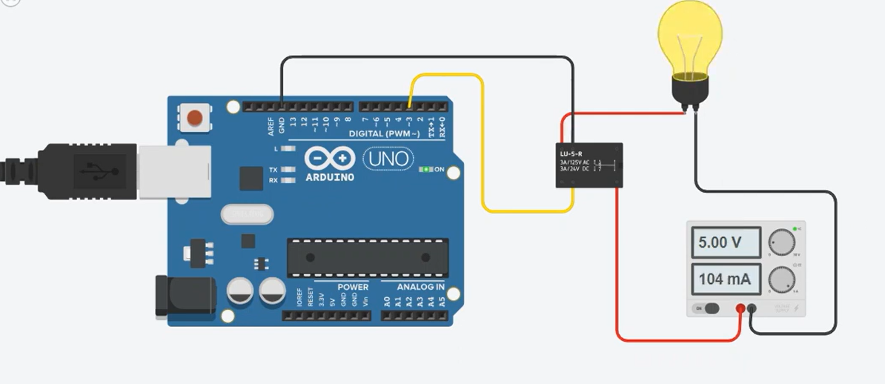
Program
// Define the digital pin connected to the relay module's IN pin
int relayPin = 7;
void setup() {
// Set the relayPin as an OUTPUT
pinMode(relayPin, OUTPUT);
}
void loop() {
// Turn the relay ON (assuming a HIGH signal activates the relay)
digitalWrite(relayPin, HIGH);
// Wait for 2 seconds
delay(2000);
// Turn the relay OFF (assuming a LOW signal deactivates the relay)
digitalWrite(relayPin, LOW);
// Wait for 2 seconds
delay(2000);
}

Working Observation:
- The program lights up the LED when the 5v relay turning on and waits for the 2 seconds delay.
- Then it goes into lights off when the 5v relay turning off, this performs the task in the DC device to create a smooth "ON and OFF" switching state.

RESULT: Relay interface is successfully implemented with Arduino microcontroller Board.

